Category: Pharmaceutical Formulations

Title of the Abstract
Presenting Author¹, Co-Author^{1,} ², Co-Author², Corresponding Author*^{,1}

¹Department Name, Institution Address; ²Department Name, Institution Address.
* emailid@email.com

The Title of the Abstract should be in Times New Roman Font, Bold and 14 points in size and the Author Names should be in Times New Roman font, 11 points in size. The Affiliation to be in Times New Roman font, 11 points in size, Italics, and the email id in Times New Roman font, 11 points in size with one line gap after the Title of the Abstract, Author Names and email id and single line spacing in between as shown above.
A maximum of 250 words in Times New Roman font, with size as 12 points, justified with a line spacing of 1.15 and a paragraph spacing of 6 points after each paragraph.
Please note that the ABSTRACT SHOULD BE limited to a ONE PAGE article and only key references can be mentioned in the format given below.
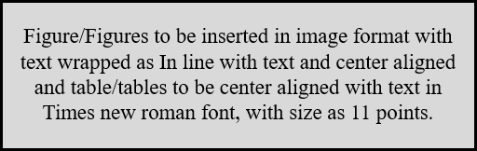

Figure 1/ Table 1: Figure/Table to be inserted as caption with Times New Roman font, size as 10 points and center aligned with single line spacing. ONLY ONE figure or Table is allowed.

- Surname First Name, Second Author,…Corresponding Author. Title of the work published.
Title of the Journal in short form, Year, Volume (Issue), Page No.
- Raychaudhuri, R., Pandey, A., Das, S., Vincent, A.P., Mutalik, S. Nanoparticle impregnated self-supporting protein gel for enhanced reduction in oxidative stress: A molecular dynamics insight for lactoferrin-polyphenol interaction, Int J Biol Macromol, 2021, 189 (2), 100–113.

